Step 1: Fork the Repository

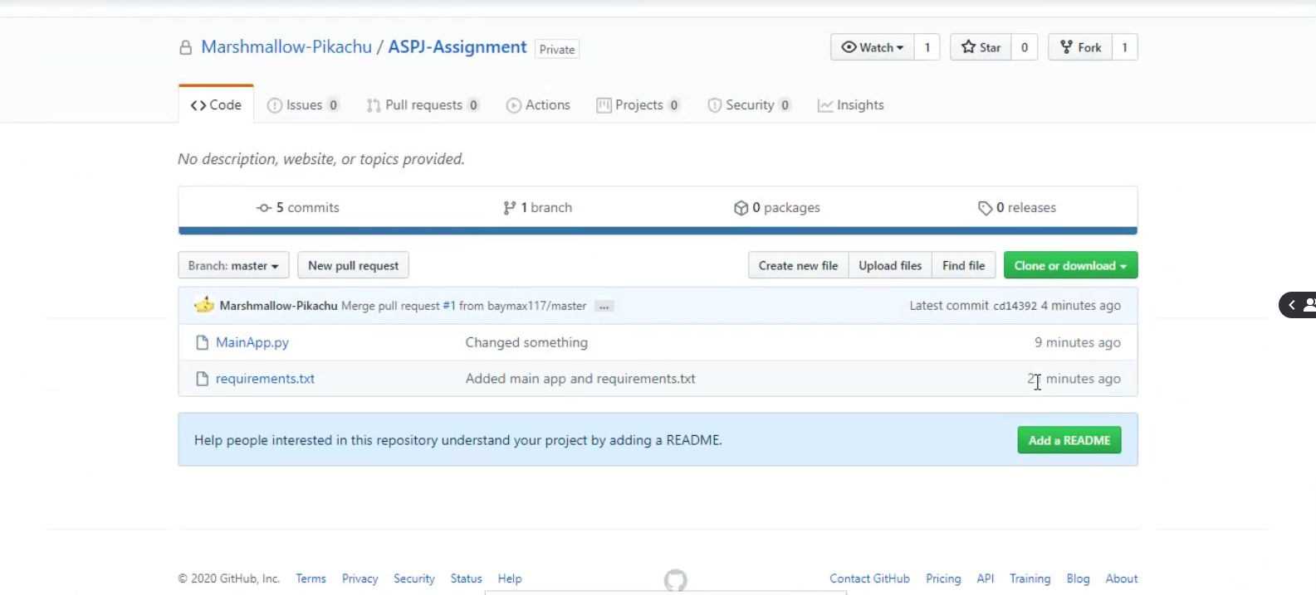

Step 2: Clone the Repository into pycharm

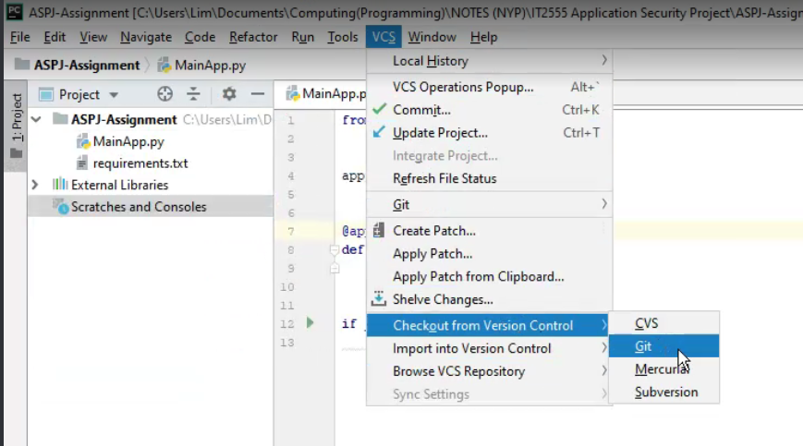

Step 3: Enter your forked repository url, remember to test it first and make sure it is successful before cloning

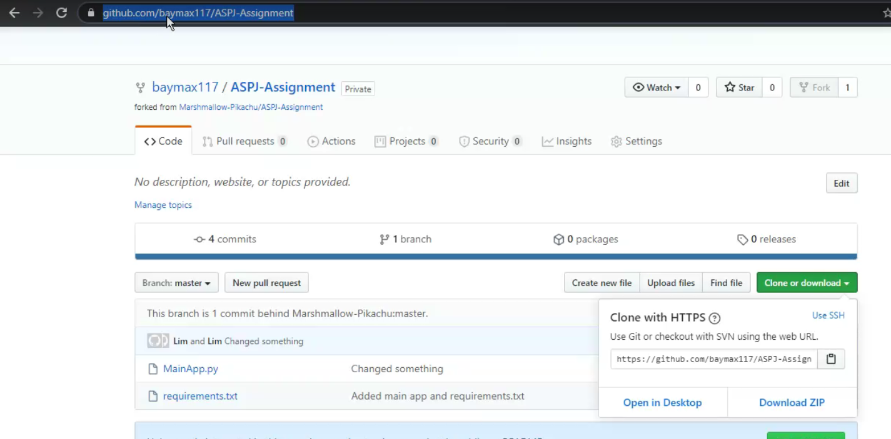

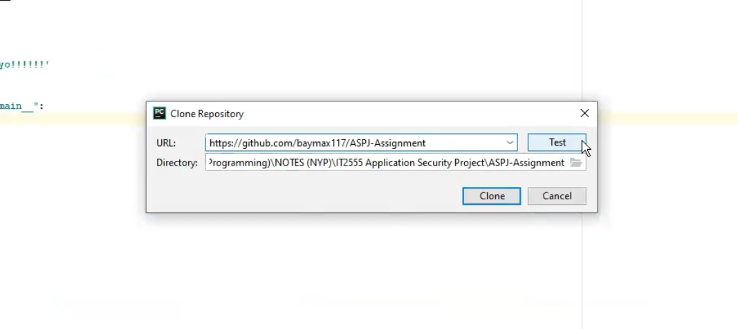

Step 4: Make your changes to the code/respository, remember to commit all changes to your local git when made

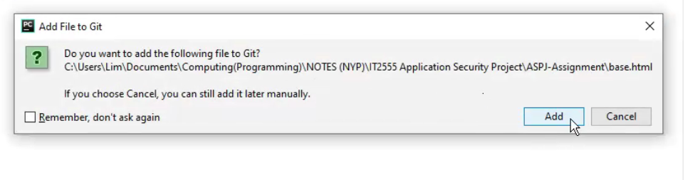

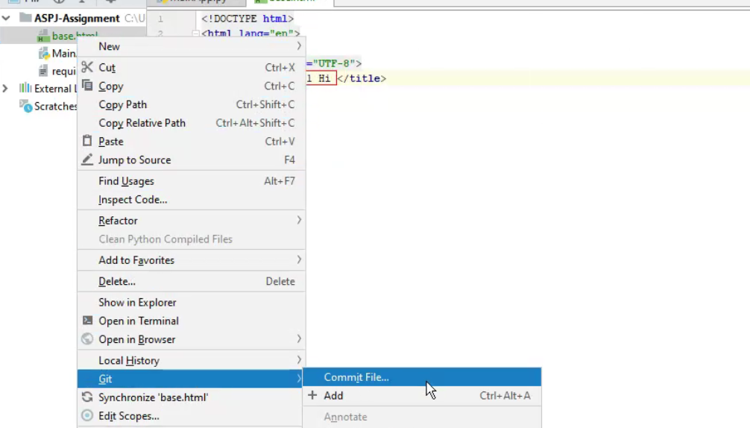

Note: Ensure that all new/edited files or checked

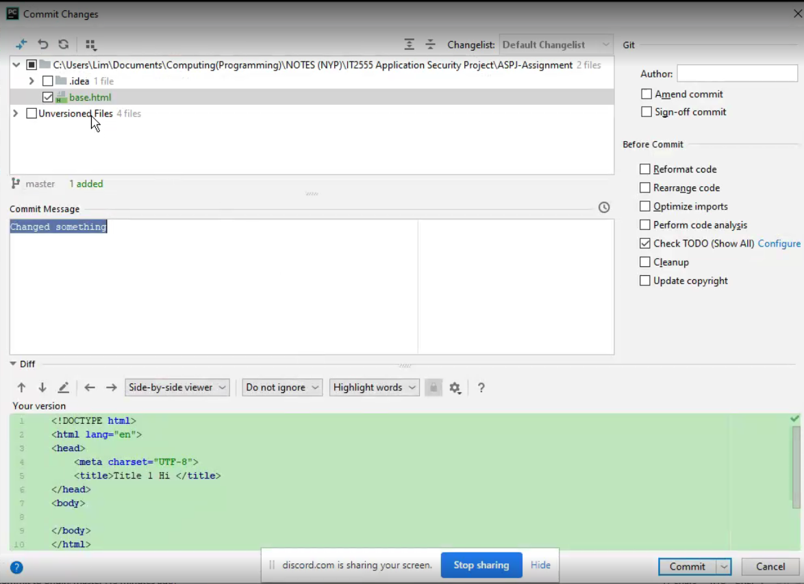

Step 5: Push repository into github, just press push if everything is there

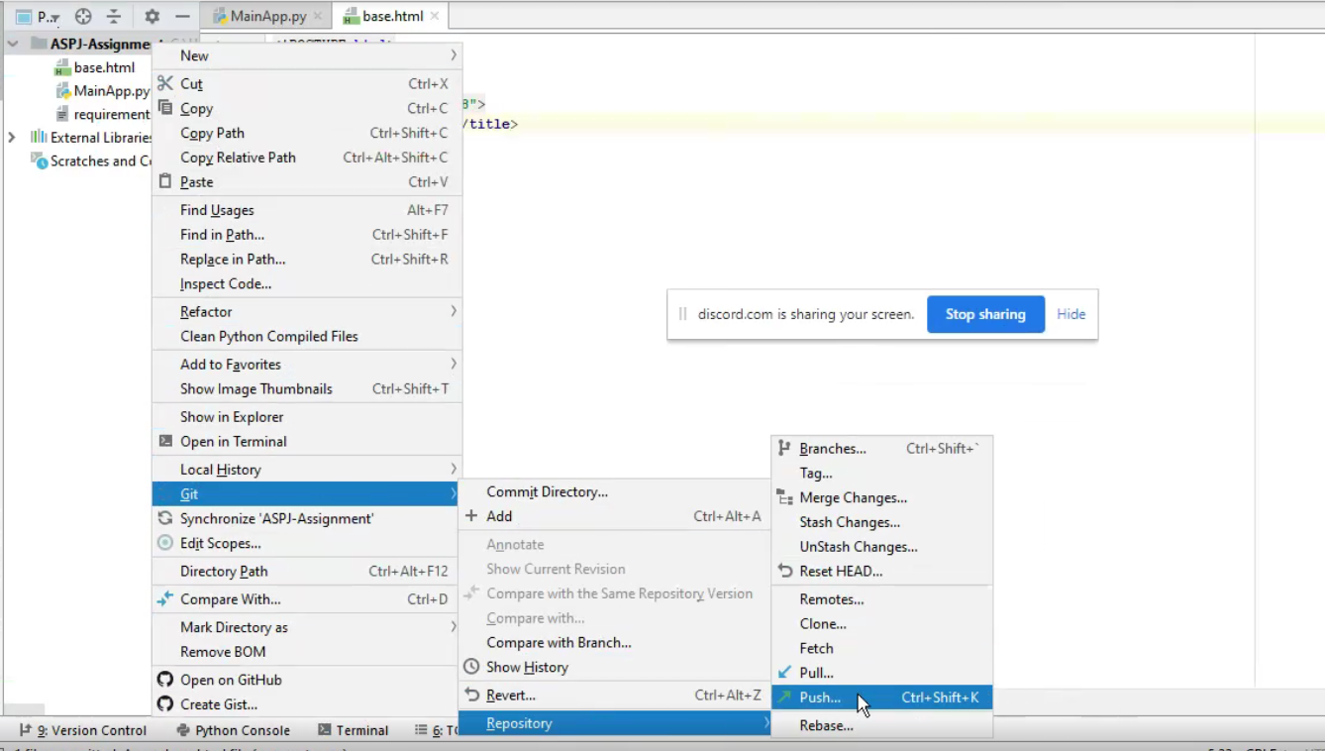

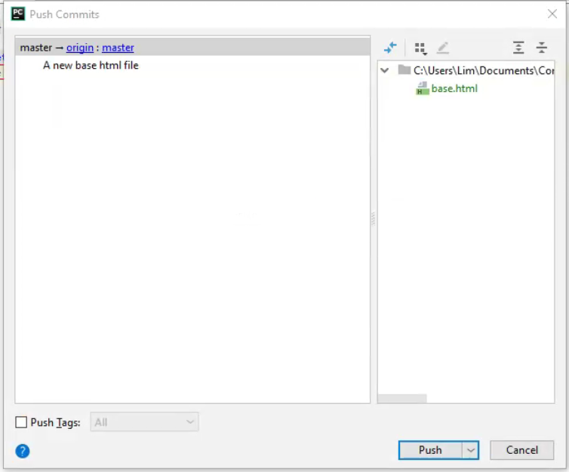

Step 7: Refresh your github page to check your changes are successful

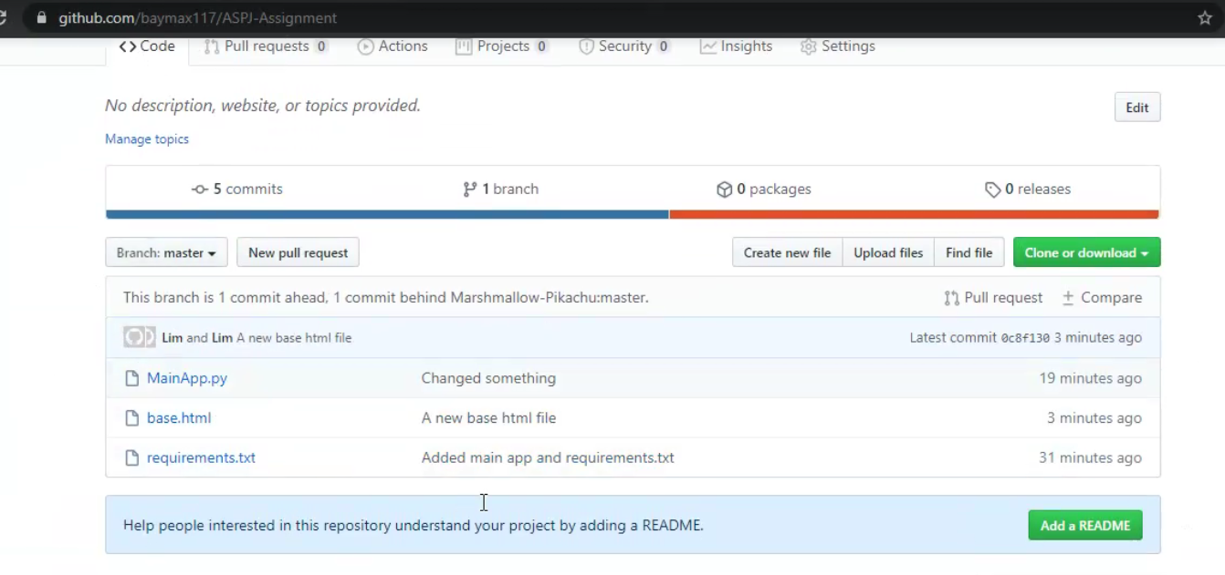

Step 8: Create a new pull request

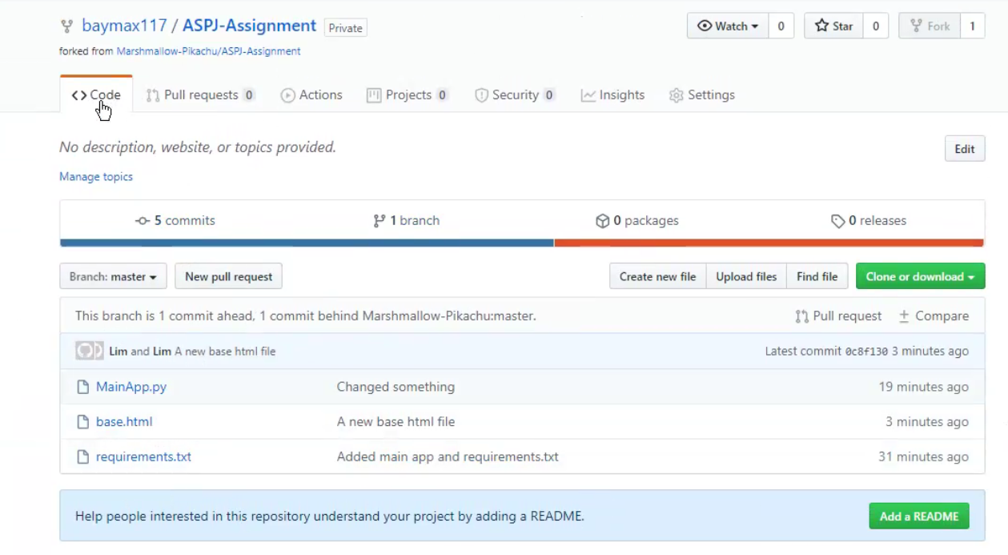

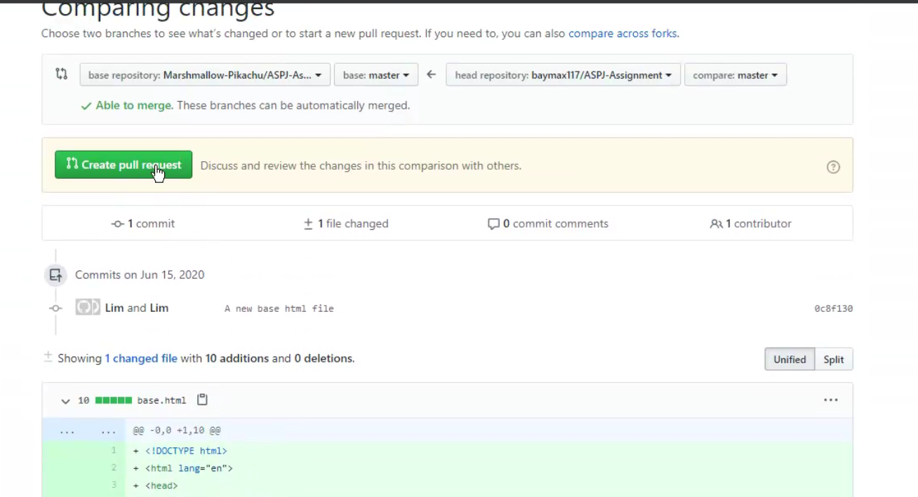

Step 9: Enter the changes you have made to the repository (important in order to keep track of what’s going on). Once done click pull request

